Hurricane Katrina
Student’s Name
Institutional Affiliation

Contents
Introduction 3
Statement of Issue 3
History and Background 3
“Who cares’ Statistics 4
Earth’s Atmosphere 4
Weather Impacts 5
The Water Cycle 6
The Science of Hurricane Katrina 6
Measurement Scales for Hurricane Katrina 7
Family Emergency 7
Survival Tips and Evacuation Plan 8
Disaster and First Aid Kits 8
Emergency Pet Plan 8
Conclusion 8
References 9

Hurricane Katrina

Introduction

Statement of Issue
This paper highlights important facts about Hurricane Katrina including historical background information, impacts, and weather-related facts. Studying this topic will help promote understanding severe weather activities and enhance disaster management and planning strategies. The audience can learn facts from Hurricane Katrina and ways to plan when such a disaster hit them. The following image shows the extent of damage that is caused by Hurricane Katrina.
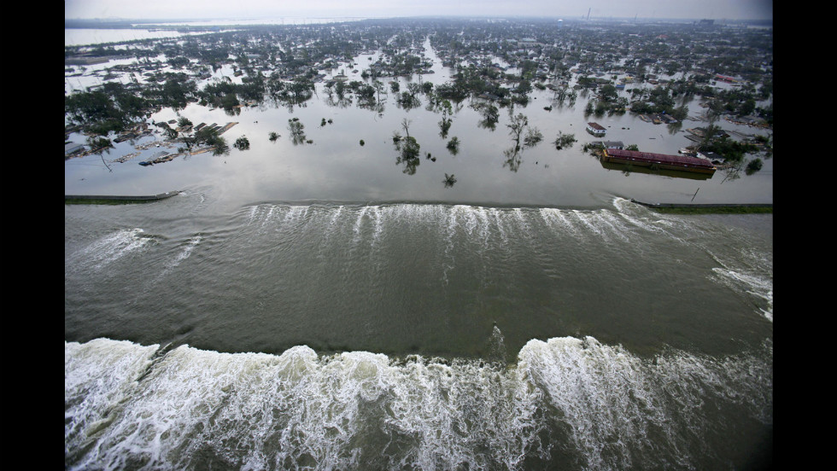
Hurricane Katrina: Source: Simmerman, 2015)

History and Background
Hurricane Katrina is one of the severe weather disasters that hit the United States in late August 2005. The hurricane affected five states, including Alabama, Florida, Georgia, Louisiana, and Mississippi. The hurricane was caused by strong winds that slammed into the Gulfport and Biloxi, which devastated the two cities (Zimmerman, 2015).

“Who cares’ Statistics
Hurricane Katrina left a devastating effect on the five states that it hit. More than 1,800 people lost their lives due to the hurricane (Lopez, 2015). Hurricane Katrina has been classified as the third deadliest and the biggest hurricanes that have ever hit the United States after the 1928 and 1900 incidents that left 3,000 and 8,000 people dead, respectively (Lopez, 2015). Compared to the other hurricanes that have been witnessed in the past years, hurricane Katrina was devastating in the number of casualties that were recorded. The economic impacts have been estimated to be about $108 billion (Lopez, 2015).

Earth’s Atmosphere
According to National Ocean Service (2020), hurricanes form over the ocean, and in most cases, they start as a tropical wave. The tropical wave begins in a low-pressure area and changes its strength as it moves through the moisture to rich tropics. National Ocean Service (2020) explains that the change in the wave movement enhances the shower and thunderstorms that result in a hurricane. As depicted in the picture below, hurricanes are created from violent storms that form over the ocean. As Warm Ocean air rises into becoming a storm, it causes more air to rush in the area of low pressure underneath. This causes the air to rise and cool, which forms clouds and thunderstorms..
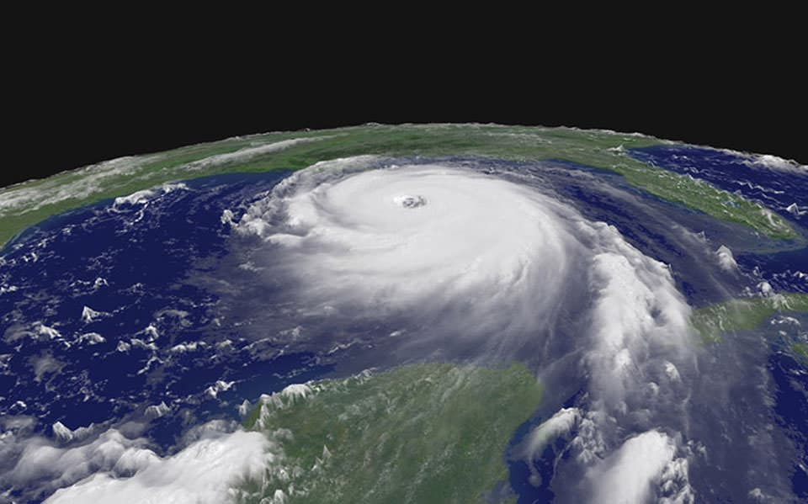
Hurricane Katrina Wave: OCEANSERRVICE. NOAA.ORG

Weather Impacts
Weather can be defined as the state of atmosphere that can be categorized based on the heat, cloudiness, dryness, sunshine, rain, and wind. In regards to hurricane Katrina, the major factors that impact weather include wind, pressure systems, ocean currents, and Coriolis force. Each of these factors contributes to the formation of hurricane Katrina in different ways. For example, hurricane Katrina begins with a pre-existing weather disturbance as a tropical wave, after which the warm water rises into the storm, which eventually creates an area of low pressure beneath the ocean (NOAA, 2020). This movement of warm ocean water and change in the pressure systems in the underneath ocean space causes air beneath to cool and rise up. The moving air is further assisted by the rotating earth, which causes the Coriolis force (Earth Observatory). The Coriolis force is important in the formation of the hurricane because it causes the air that rushes into the center of the earth’s hemisphere to change their movement to counter-clockwise the earth’s rotational movement (Earth Observatory).

The Water Cycle
The water cycle describes how water moves from the earth’s surface to the atmosphere and as it cools again to the surface. The water cycle shows the evaporation, condensation, and precipitation of the earth’s water. Precipitation is understood as the process in which atmospheric water vapor condenses and falls under gravity from the atmosphere. The following image shows the water cycle and the earth’s water content. It is estimated that 15% of the water that enters the earth's surface comes from precipitation.
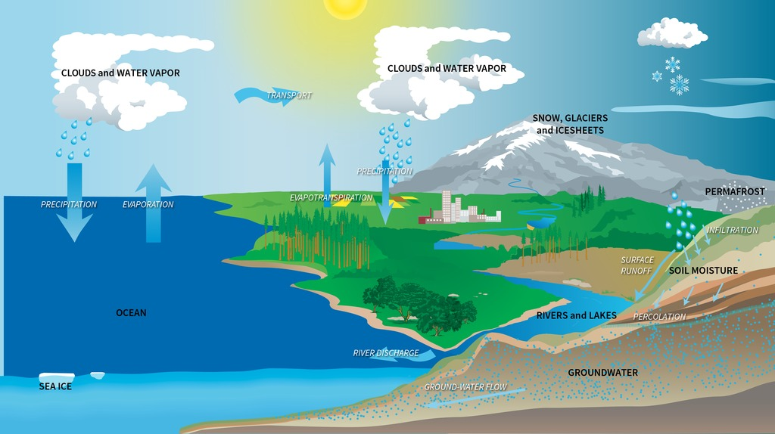
Water Cycle: Source: olc.worldbank.org

The Science of Hurricane Katrina
A hurricane is defined as a forcefully powerful rotating storm that emanates from tropical wave. According to Pickrell (2005), hurricanes are characterized by thunderstorms that move over warm tropical waters. The conditions that create hurricanes include sea-surface temperature that exceeds 27 degrees celsious and calm surrounding atmosphere. These conditions create evaporation of large water quantities that condense into clouds and rain, which releases the heat in the process. Pickrell (2005) explains that it is this heat energy that combines with the earth’s rotation to create a moving forceful storm known as hurricane. Hurricanes occur in tropical regions, also known as typhoons such as South-East Asia, the Pacific region, and cyclones in the Indian Ocean (Pickrell, 2005). Hurricane travels at a speed of 23 miles per hour (Pickrell, 2005).

Measurement Scales for Hurricane Katrina
Hurricanes are measured using various tools, but the main one is Saffir-Simpson Hurricane Wind Scale, which includes rating from 1 to 5 based on the hurricane’s wind speed. This scale was developed by civil engineer Herbert Saffir together with Robert Simpson in 1971, but was introduced in the general public in 1973 (National Weather Service). Hurricane Katrina of 2005 was moving at a speed of between 144 to 162 kilometers per hour. Based on Saffir-Simpson Hurricane Wind Scale, this hurricane would be classified as category II hurricane and it is extremely dangerous because it can cause extensive damage (National Weather Service).

Family Emergency
Events like hurricanes often begin early and people can find out information from the media and other sources like friends and family. In case it happens, my family emergency plan includes evacuation as early as possible to areas that are considered safe. Hurricane Katrina of 2005 claimed many lives because of slow response from the government. I think that it would be better to begin the first step individual, take the public means out of the state if possible once the news breaks out.

Survival Tips and Evacuation Plan
Evacuation involves packing and leaving the place. In case of a hurricane Katrina, one needs to pack light but important things like food and sleeping gear. The evacuation should begin immediately once one gets the news because any delays only brings the problem closer.

Disaster and First Aid Kits
In the disaster and first aid kit, I would include bandages, paracetamol or asprin tablets. Also, disinfectants in case one get a wound that needs immediate attention.

Emergency Pet Plan
Pets are part of the family and it would be like leaving a family member behind during such disasters. Therefore, my emergency pet plan will involve taking it with me during the evacuation. Reducing the luggage will be important to ensure that important things like pet can be accommodated in that movement.

Conclusion
In conclusion, disasters like hurricanes often cause extensive damages, especially when there are no immediate evacuation strategies. This research has examined the concept of hurricane Katrina of 2005 and the impacts as well as the survival techniques that can reduce the casualties. Even though the government is often blamed for the casualties, it is important for people to take individual responsibilities towards protecting themselves during such disasters.

References
Earth Observatory. “Cloud Spirals and Outflow in Tropical Storm Katrina.” NASA Earth Observatory. Retrieved from https://earthobservatory.nasa.gov/images/5827/cloud-spirals-and-outflow-in-tropical-storm-katrina
Lopez, G. (2015 August, 28). “Hurricane Katrina, in 7 Essential Facts.” Vox. Retrieved from https://www.vox.com/2015/8/23/9191907/hurricane-katrina
National Ocean Service. (2020). How do Hurricanes Form? NOAA. Retrieved from https://oceanservice.noaa.gov/facts/how-hurricanes-form.html
National Weather Service. (2005 August ). “Hurricane Katrina –August 2005.” NOAA. Retrieved from https://www.weather.gov/mob/katrina
National Weather Service. Saffir-Simpson Hurricane Scale. NOAA. Retrieved from https://www.weather.gov/mfl/saffirsimpson
Pickrel, J. (2005 September, 21). “Hurricane Katrina-The Aftermath.” New Scientists. Retrieved from https://www.newscientist.com/article/dn9960-hurricane-katrina-the-aftermath/
Zimmerman, K. A. (2015 August, 27). “Hurricane Katrina: Facts, Damage & Aftermath.” Live Science. Retrieved from https://www.livescience.com/22522-hurricane-katrina-facts.html

